**SQL DATABASE MANAGEMENT SYSTEM**

**Sql**🡪 structured query language, used to communicate with the databases

**Rdbms**🡪 relational database management system, software used to manage database (mysql, oracle, postgres sql are some of the rdbms software)

**Query**🡪requests made to the database for specific information

**Keys in sql**🡪

1. **Primary key**:

The PRIMARY KEY constraint **uniquely identifies each record in a table**. Primary keys must contain UNIQUE values, and cannot contain NULL values. A table can have only ONE primary key

1. **Surrogate key**:

type of primary key, that has no mapping to the real world

1. **Natural key**:

Type of primary key which has some mapping to the real world

1. **Foreign key**:

Attribute that is stored in a database table to link another table in the database, it stores primary key of a row in another other table

1. **Composite key**:

Key which has two attributes in the column both attributes combine together to form a composite key, only together they can uniquely identify the table

**SQL**

**DML**

(data manipulation language)

**DCL**

(data control language)

**DDL**

(data definition language)

**DQL**

(data query language)

**DQL🡪** used to query the database for information, get the information that is already stored in the database (eg: SELECT)

**DDL🡪** used for defining database schemas (eg: CREATE, DROP, TRUNCATE, ALTER, RENAME)

**DCL🡪** used for controlling access to the data in the database (eg: GRANT, REVOKE)

**DML🡪** used for inserting, updating and deleting data from the database

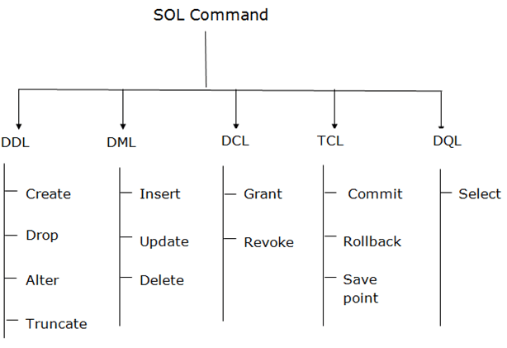

**BASIC 6 DATA TYPES IN SQL:**

**Int🡪** whole numbers

**Decimal(m,n)🡪** decimal numbers, m(total no of digits), n(number of digits after decimal point)

**Varchar(10)🡪**  string of text of length 10

**Blob🡪** binary large objects, like image files can be stored in blob

**Date🡪** (YYYY-MM-DD)

**Timestamp🡪** (HH:MM:SS)

**BASIC QUERIES IN SQL:**

* **Create table🡪**

Capture.PNG

**Command used🡪** create table (table name) (….)

**Table name🡪** student

**Data types🡪** integer (int), String (varchar)

**Keys🡪** primary key

* **Insert values into table🡪**

Capture.PNG

Capture.PNG

**Command used🡪** insert into (table name) values(….)

**Key words🡪** insert

* **Select command🡪**

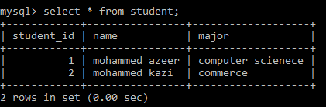

* **To add extra column in a table🡪**

**Capture.PNG**

**Command used🡪** alter table add (table name) (column name) data type

**Key words used🡪** alter, add

* **To add default value in a column🡪**

**Capture.PNG**

If the user leaves any column empty the default values is inserted into the column

Here, if major is left empty the value ‘not decided’ is inserted into the row

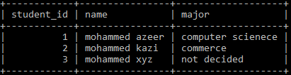

**Command used🡪** default ‘text to add’

**Update commands🡪**

Capture.PNG

Capture.PNG

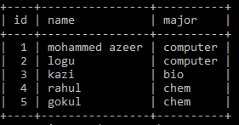 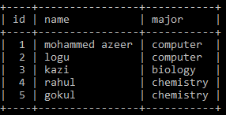

**Command used🡪** update (table name) set (xx) where(yy)

**Key words used🡪** update, set, where

**Order by🡪**

This command is used to order the information based on the give constraints

**by default** it returns the data in **ascending order**

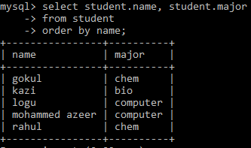

To get the values is descending order use the key words **desc**

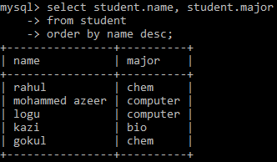

**In command🡪**

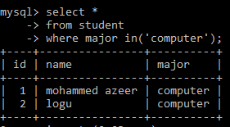

in read like this🡪 select * from student where major **is(in)** (‘computer’)

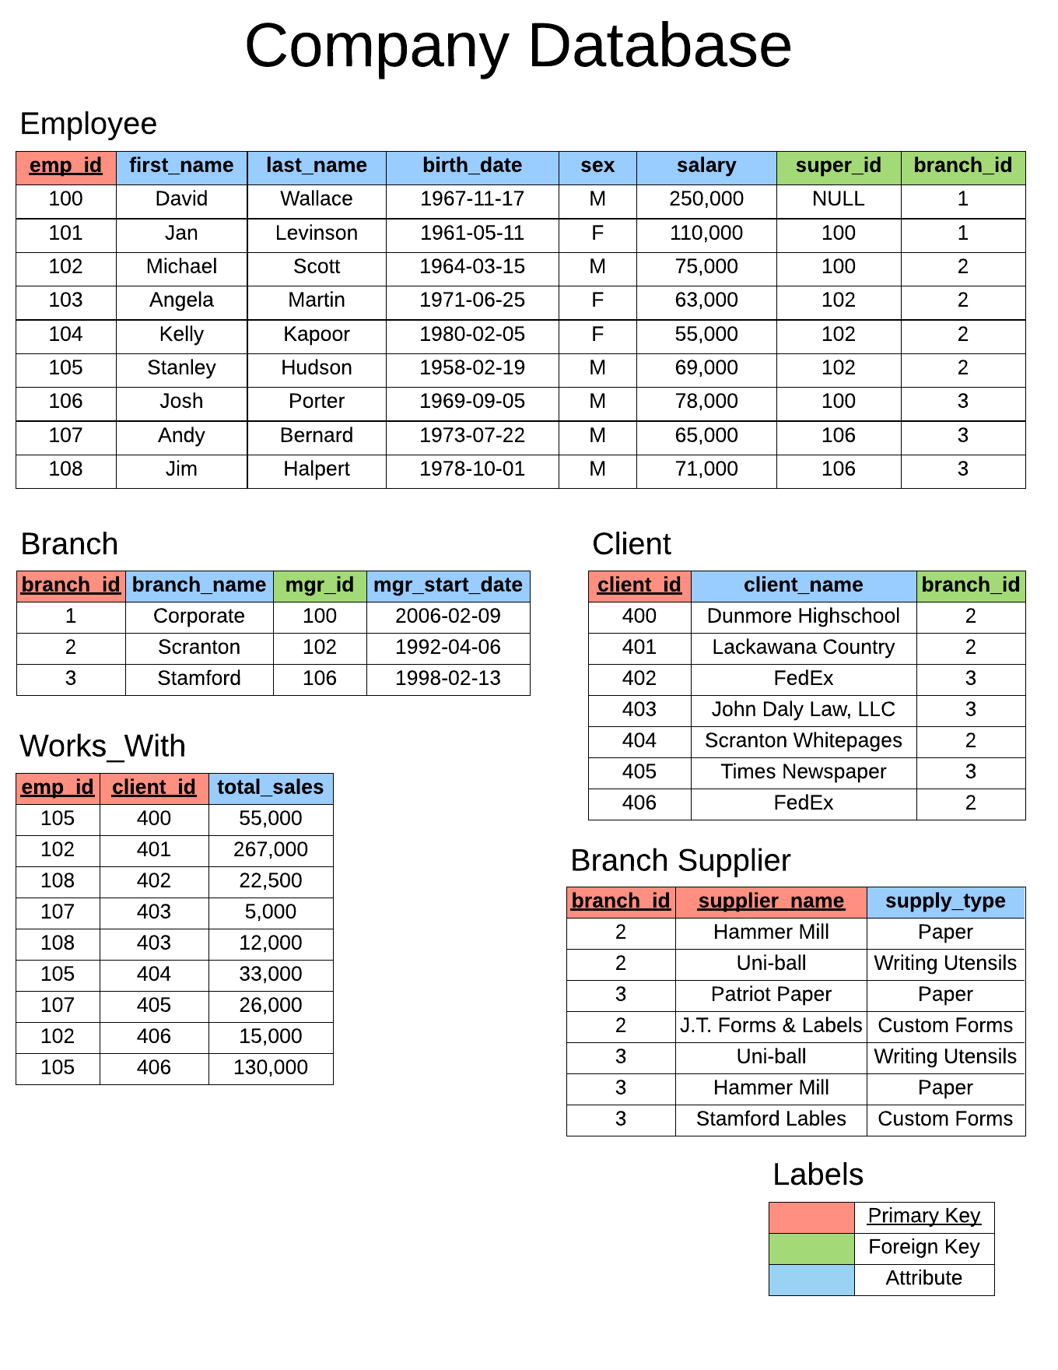

**Creating employee table🡪**

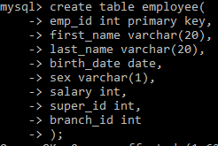

We cannot set super_id and branch_id as foreign key , since the table has not been created.

After creating the table we have to add the foreign keys using alter commmand

**Creating branch table🡪**

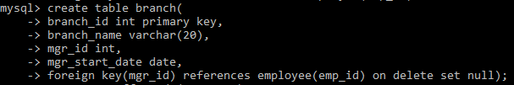

**Adding foreign keys in employee table🡪**

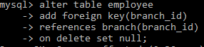 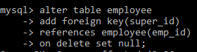

**Creating client table🡪**

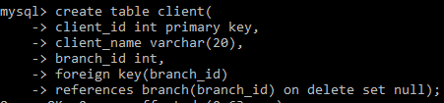

**Creating works_with table🡪**

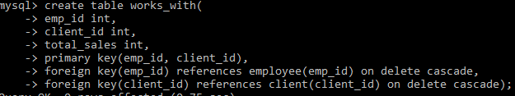

**Creating branch_supplier table🡪**

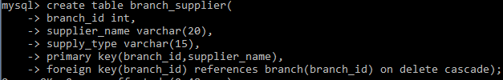

**Inserting values into tables🡪**

**Inserting value in employee table🡪**

**Capture.PNG**

Here the last two columns super_id and branch_id are set null initially null because we have not inserted values into the branch table yet

**Inserting values into branch table🡪**

**Capture.PNG**

Now we have inserted value into the branch table, so we should update the employee table and we can add the values into the employee table normally as the foreign key is established

Capture.PNG

Capture.PNG

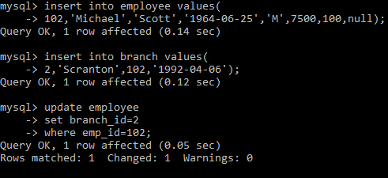

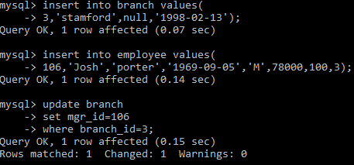

**Employee and branch table has been created🡪**

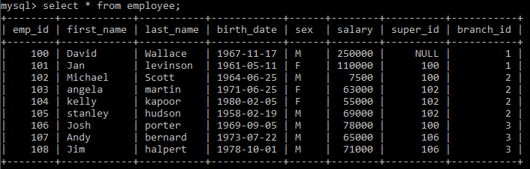

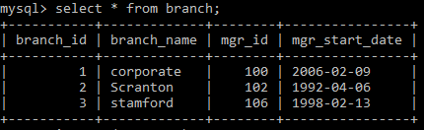

**Creating client table🡪**

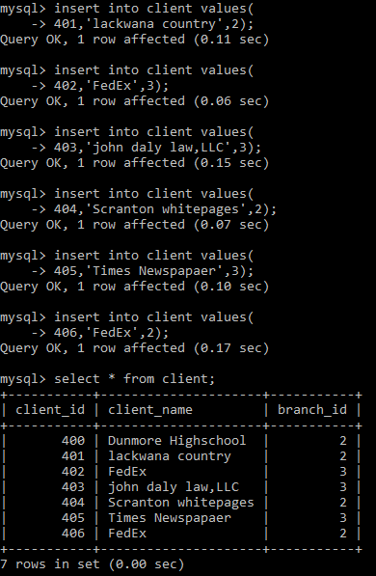

**Creating works_with table🡪**

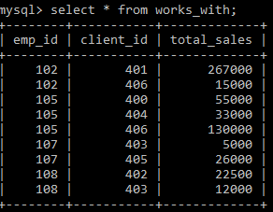

**Creating branch_suppplier table🡪**

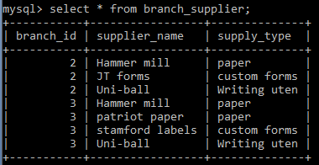

**BASIC QUERIES TO FETCH THE DATA FROM THE DATABASE**

* **Find all employees ordered by their salary🡪**

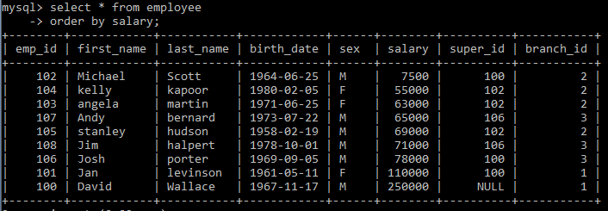

* **Find all employees ordered by sex and then name🡪**

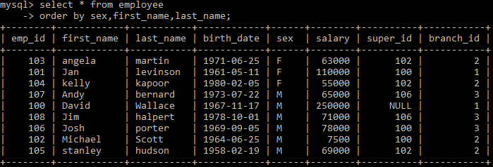

* **Select the first 5 employee from the table🡪**

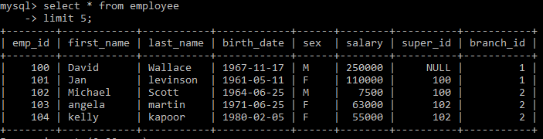

* **Find the forename and surname of all employees**

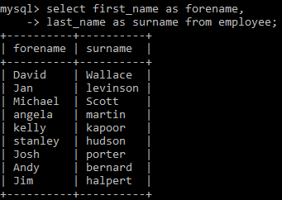

* **Find out all the different genders**

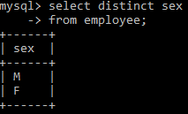

**QUERIES USING BASIC SQL FUNCTIONS🡪**

* **Count function🡪count number of employees from employee table**

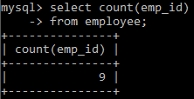

* **Find number of female employees born after 1970**

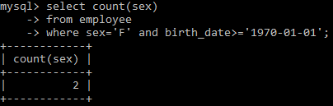

* **Average(avg)🡪 find the average of all employee’s salary**

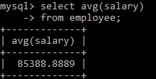

* **Find out how many males and females there are(group by)**

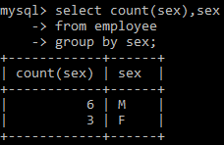

* **Find total sales of each sales man from works_with table(group by)**

